Criando um novo filter

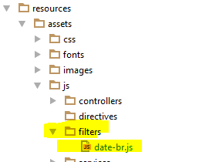

Filters/data-br.js

*// date: 'dd/MM/yyyy'***angular**.module(**'app.filters'**).filter(**'dateBr'**, [**'$filter'**, **function**($filter) {  
 **return function**(input) {  
 **return** $filter(**'date'**)(input, **'dd/MM/yyyy'**);  
 }  
}]);

Chamando o filter.js

Na app.blade

*<!-- FILTERS !-->*<**script src="**{{ asset(**'build/js/filters/date-br.js'**) }}**"**></**script**>

Dentor de App.js chamando o filter

**var *app*** = **angular**.module(**'app'**, [**'ngRoute'**, **'angular-oauth2'**, **'app.controllers'**, **'app.services'**, **'app.filters'**]);  
  
**angular**.module(**'app.controllers'**, [**'ngMessages'**, **'angular-oauth2'**]);  
**angular**.module(**'app.filters'**, []);  
**angular**.module(**'app.services'**, [**'ngResource'**]);

Passando o filter no list

<**tbody**>  
 <**tr ng-repeat="o in projects"**>  
 <**td**>{{o.id}}</**td**>  
 <**td**>{{o.name}}</**td**>  
 <**td**>{{o.client.data.name}}</**td**>  
 <**td**>{{o.progress}}</**td**>  
 <**td**>{{o.status}}</**td**>  
 <**td**>{{o.due_date | dateBr}}</**td**>  
 <**td**>  
 <**a ng-href="#/projects/{{o.id}}/edit"**>Editar</**a**>  
 <**a ng-href="#/projects/{{o.id}}/remove"**>Excluir</**a**> </**td**>  
 </**tr**>  
</**tbody**>